**Exploratory Data Analysis**

**Actionable Insights, Trends, and Strategic Recommendations from EDA**

**1. Defaulter Ratio (Pie Chart)**

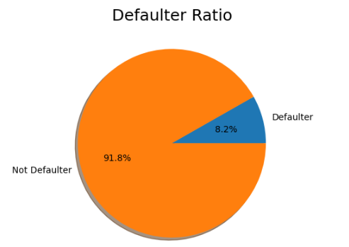

* **Insight:** The defaulter ratio indicates that only 8.2% of the borrowers defaulted on their credit cards, while 91.8% did not default. This shows a significant class imbalance in the dataset.
* **Trend:** A low defaulter rate is observed, which is common in credit risk datasets as most customers generally repay their debts.
* **Recommendation:**
  + **Modeling Strategy:** Given the class imbalance, consider using techniques such as SMOTE (Synthetic Minority Over-sampling Technique) to oversample the minority class (defaulters) or use algorithms like XGBoost that handle class imbalance well.
  + **Risk Management:** Although the defaulter rate is low, financial institutions should still focus on improving prediction accuracy for the minority class to avoid potential financial losses.

**2. Age Distribution (Density Plot)**

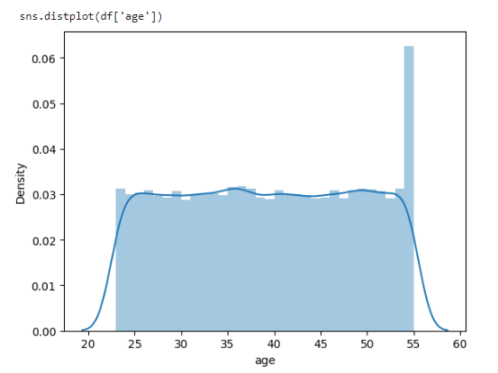

* **Insight:** The age distribution of the borrowers is fairly uniform across the age ranges of 20 to 55, with noticeable peaks around the ages of 30 and 55.
* **Trend:** Borrowers in their early 30s and mid-50s represent significant portions of the dataset, potentially indicating life stages associated with higher financial activity (e.g., buying homes, retirement planning).
* **Recommendation:**
  + **Targeted Marketing:** Financial institutions should tailor their product offerings to these age groups, considering their financial needs. For example, younger borrowers may benefit from lower interest rates on loans, while older borrowers may be interested in retirement planning products.
  + **Risk Profiling:** Age can be a factor in credit risk profiling. Institutions should assess the correlation between age and default risk to refine their credit scoring models.

**3. Credit Score vs. Credit Card Default (Box Plot)**

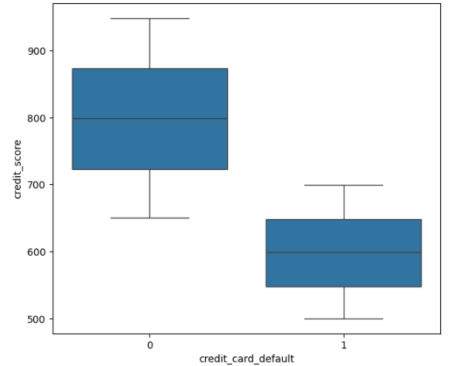

* **Insight:** The box plot shows that individuals who defaulted have significantly lower credit scores (around 600) compared to those who did not default (around 800).
* **Trend:** A clear inverse relationship between credit score and default risk is observed, with lower credit scores being associated with a higher likelihood of default.
* **Recommendation:**
  + **Credit Scoring Systems:** Enhance credit scoring models by integrating additional behavioral and transactional data to predict defaults more accurately.
  + **Risk-Based Pricing:** Implement risk-based pricing strategies where borrowers with lower credit scores are charged higher interest rates or required to provide additional collateral.

**4. Credit Limit Used vs. Credit Card Default (Box Plot)**

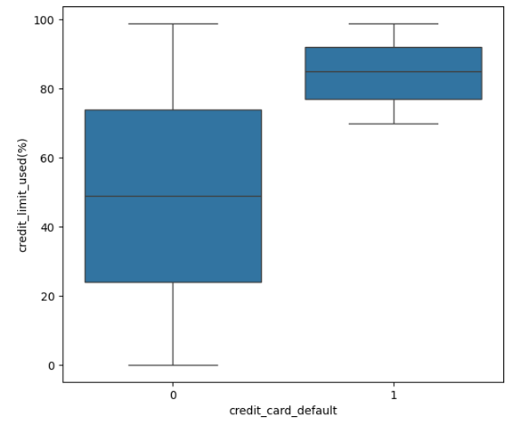

* **Insight:** Defaulters typically use a much higher percentage of their credit limit (around 80-90%) compared to non-defaulters (around 40-60%).
* **Trend:** High utilization of credit limits is a strong indicator of financial distress and increased default risk.
* **Recommendation:**
  + **Credit Limit Management:** Financial institutions should monitor customers with high credit utilization closely and consider proactive measures such as offering financial counseling or adjusting credit limits.
  + **Early Warning Systems:** Develop early warning systems that flag customers who consistently use a high percentage of their credit limit, allowing for pre-emptive actions to mitigate default risk.

**5. Net Monthly Income by Occupation Type (Bar Chart)**

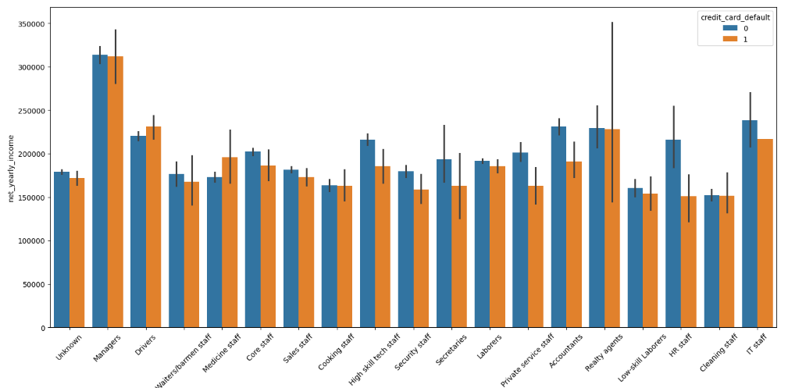

* **Insight:** Income levels vary significantly across different occupation types, with certain occupations like Managers and IT Staff earning higher than others, such as Laborers and Cleaning Staff.
* **Trend:** Higher-income occupations generally show lower default rates, while lower-income occupations may have higher default rates.
* **Recommendation:**
  + **Customized Credit Products:** Offer tailored credit products that align with the income levels of different occupations. For example, lower-income groups could benefit from microloans with manageable repayment terms.
  + **Income Verification:** Ensure robust income verification processes are in place, especially for high-risk occupations, to accurately assess borrowers' repayment capacity.

**6. Gender Distribution and Default (Bar Chart)**

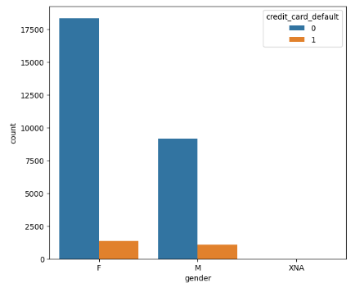

* **Insight:** The majority of the dataset comprises female borrowers, with both genders showing a relatively low default rate. However, a slight imbalance is observed with more female borrowers represented.
* **Trend:** Gender distribution suggests that both male and female borrowers are equally prone to default, with no significant gender-based bias in default rates.
* **Recommendation:**
  + **Gender-Neutral Policies:** Maintain gender-neutral credit policies, ensuring that creditworthiness assessments are based purely on financial indicators rather than demographic factors.
  + **Diversity in Lending:** Consider strategies to ensure that lending products are equally accessible to all genders, promoting financial inclusion across diverse demographics.

**Conclusion**

The exploratory data analysis provides valuable insights into the patterns and factors influencing credit card defaults. By leveraging these insights, financial institutions can implement targeted strategies to manage credit risk more effectively, enhance customer satisfaction, and maintain financial stability. The combination of data-driven insights and strategic recommendations forms the foundation for a robust credit risk management framework.

**Additional Insights and Recommendations Based on the Box Plots**

**1. Net Yearly Income, No. of Days Employed, Yearly Debt Payments (Box Plots)**

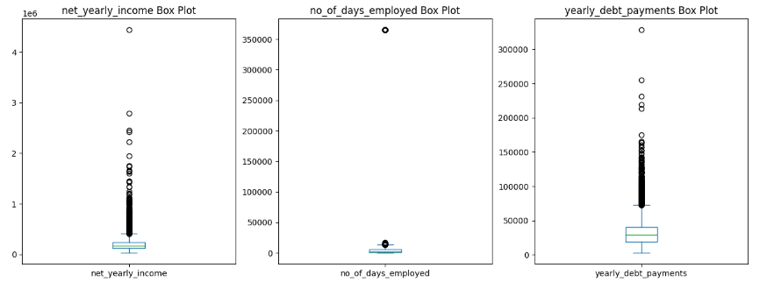

* **Insight:**
  + **Net Yearly Income:** The net yearly income box plot shows a large number of outliers on the higher end, indicating that while most individuals have moderate incomes, a few individuals earn significantly more. The majority of the data is concentrated at the lower end of the income spectrum.
  + **No. of Days Employed:** The box plot for the number of days employed shows a significant outlier far above the rest of the data points, indicating that one or a few individuals have been employed for an unusually long period, potentially due to incorrect data entry.
  + **Yearly Debt Payments:** Similar to income, yearly debt payments also show a concentration of data at the lower end, with several outliers indicating higher debt payments.
* **Trend:**
  + There is a significant disparity in income and debt payments, with most individuals earning and paying within a certain range, but a few outliers represent very high values.
  + The extreme outlier in the "No. of Days Employed" may suggest a data quality issue that needs further investigation.
* **Recommendation:**
  + **Outlier Management:** Implement robust data cleaning processes to investigate and address potential data entry errors, especially the extreme outlier in the "No. of Days Employed" variable.
  + **Targeted Lending:** Financial institutions should consider offering differentiated financial products to individuals in the higher-income bracket, who may have different financial needs compared to the majority of borrowers.
  + **Debt Repayment Strategies:** Develop personalized debt repayment plans for borrowers with higher yearly debt payments to mitigate default risk.

**2. Credit Limit and Credit Score (Box Plots)**

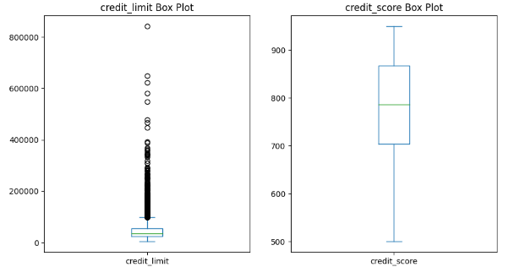

* **Insight:**
  + **Credit Limit:** The credit limit box plot reveals that most borrowers have relatively low credit limits, but there are outliers with significantly higher limits. This could indicate that a small portion of the population is being offered much higher credit limits, possibly due to higher income or better creditworthiness.
  + **Credit Score:** The box plot for credit scores shows a wide range, with most borrowers falling between a credit score of 600 and 900. A higher credit score is generally indicative of better creditworthiness.
* **Trend:**
  + Higher credit limits are granted to a select few, likely those with higher income or better credit histories.
  + Credit scores vary widely among borrowers, highlighting the diverse credit profiles within the dataset.
* **Recommendation:**
  + **Credit Limit Adjustment:** Regularly reassess and adjust credit limits based on changes in borrowers’ financial circumstances and credit behavior. This will help in managing risk and maintaining healthy credit exposure.
  + **Credit Scoring Enhancements:** Consider using advanced credit scoring models that incorporate more dynamic factors such as recent financial behavior and broader financial data to provide a more accurate assessment of creditworthiness.
  + **Customer Education:** Financial institutions should provide credit education programs to help customers understand the factors that affect their credit score and how to improve it, which can lead to better credit management and reduced default risk.

**Conclusion**

The box plots provide a deeper understanding of the distribution of key financial variables within the dataset, highlighting outliers and trends that could impact credit risk management strategies. By implementing the recommendations derived from these insights, financial institutions can better manage risk, improve customer segmentation, and tailor financial products to meet the diverse needs of their customers.